|  |
| --- |
| **Binomial Distribution**  Suppose X denotes the number of successes in a sequence of n Bernoulli trials and let the probability of success in each trial be p. Then X is said to follow a **Binomial distribution** with parameters n and p if the probability distribution of X is given by    **Mean and variance of the Binomial distribution:**    **Recurrence relation for central moments of Binomial Distribution:**  **Moment generating function of the Binomial Distribution:** |
| **Poisson Distribution**  A random variable X that takes on one of the values 0, 1, 2, . . . is said to be a Poisson random variable with parameter λ if, for some λ>0    **Poisson distribution as a limiting case of the Binomial distribution:**  The Poisson random variable has a tremendous range of applications in diverse areas because it may be used as an approximation for a binomial random variable with parameters (n, p) when n is large and p is small enough so that np is of moderate size.  The Poisson distribution is a limiting case of the binomial distribution under the following conditions:  n, the no of trails is indefinitely large, i.e. n → ∞.  p , the constant probability for the success of each trail is indefinitely small, i.e. p → 0.  np =λ is finite.  **Moment Generating Function of the Poisson distribution=**  **Mean of the Poisson distribution=**  **Variance of the Poisson distribution=**  **In general, any** **order central moment for Poisson distribution=** |

**CONTINUOUS RANDOM VARIABLES**

A random variable which takes non-countable infinite number of values is called discrete random variable. Example: length of time during which a vacuum tube is installed in a circuit functions is a continuous RV.

**Probability Density Function (PDF)**

Suppose X is a continuous RV such that



Then f(x) is called a pdf of X, provided f(x) satisfies the following conditions:



**Cumulative Distribution Function (CDF):**

Cdf of continuous random variable X is defined by F(x) = P(X ≤ x) where x is a real number (– ∞ < x < ∞) such that



**Mathematical Expectation:**

Using the pdf or the distribution function, we can obtain the average value/mean/expected value of the continuous r.v. X.





Expectation of a constant is that constant itself i.e. E(a) = a, if a is a constant

**Variance: **

**Standard Deviation** 

**NORMAL DISTRIBUTION**

The normal distribution was introduced by the French mathematician Abraham De Moivre in 1733, who used it to approximate probabilities associated with binomial random variables when the binomial parameter n is large. It is also known as the Gaussian distribution and the bell curve. Many things closely follow a Normal Distribution such as heights of people, size of things produced by machines, errors in measurements, blood pressure, marks on a test etc.

**Definition:**

A continuous random variable X is said to follow Normal distribution with parameters mean μ and variance σ 2 if its probability density function (PDF) is given by:



If random variable X follows Normal distribution with parameters μ and σ 2 then it can be written as X~ N( μ, σ).

The Normal Distribution has:

1. Mean = median = mode= μ
2. Symmetry about the center
3. 50% of values less than the mean and 50% greater than the mean
4. Var= σ 2
5. Moment Generating Function (MGF)=

**Area property of normal distribution:**

The area under the bell-shaped curve of normal distribution denotes probability. The total area under the curve is equal to one. The normal curve approaches, but never touches, the x-axis:

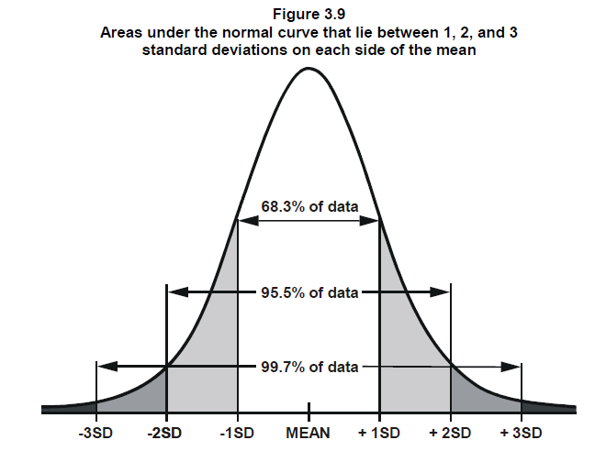

**Standard Normal Variate( SNV):**

A standard normal variate is a normal variate with mean µ=0 and standard deviation σ =1 with a probability density function is



 is called Standard Normal Variate.

In general, Central moments of odd powers of a normal distribution is zero. 

**Central moments of even powers** is given by 

**EXPONENTIAL DISTRIBUTION**

The exponential distribution is one of the widely used continuous distributions. It is often used to model the time elapsed between events suppose we are posed with the question- How much time do we need to wait before a given event occurs?  
The answer to this question can be given in probabilistic terms if we model the given problem using the Exponential Distribution.

**Definition:** A Continuous random variable X is said to follow an exponential distribution or negative exponential distribution with parameter λ>0, If its pdf is given by:



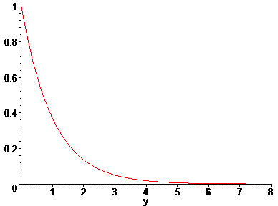

**Mean of Exponential Distribution **

**Variance of Exponential Distribution:**

**Memoryless property:**

**UNIFORM DISTRIBUTION:**

A continuous r. v X is said to follow a uniform or rectangular distribution in any finite interval, if its probability density function is a constant in that interval.

If X follows a uniform distribution , then



**Mean :** E(X) = 

**Variance:** V(X): 

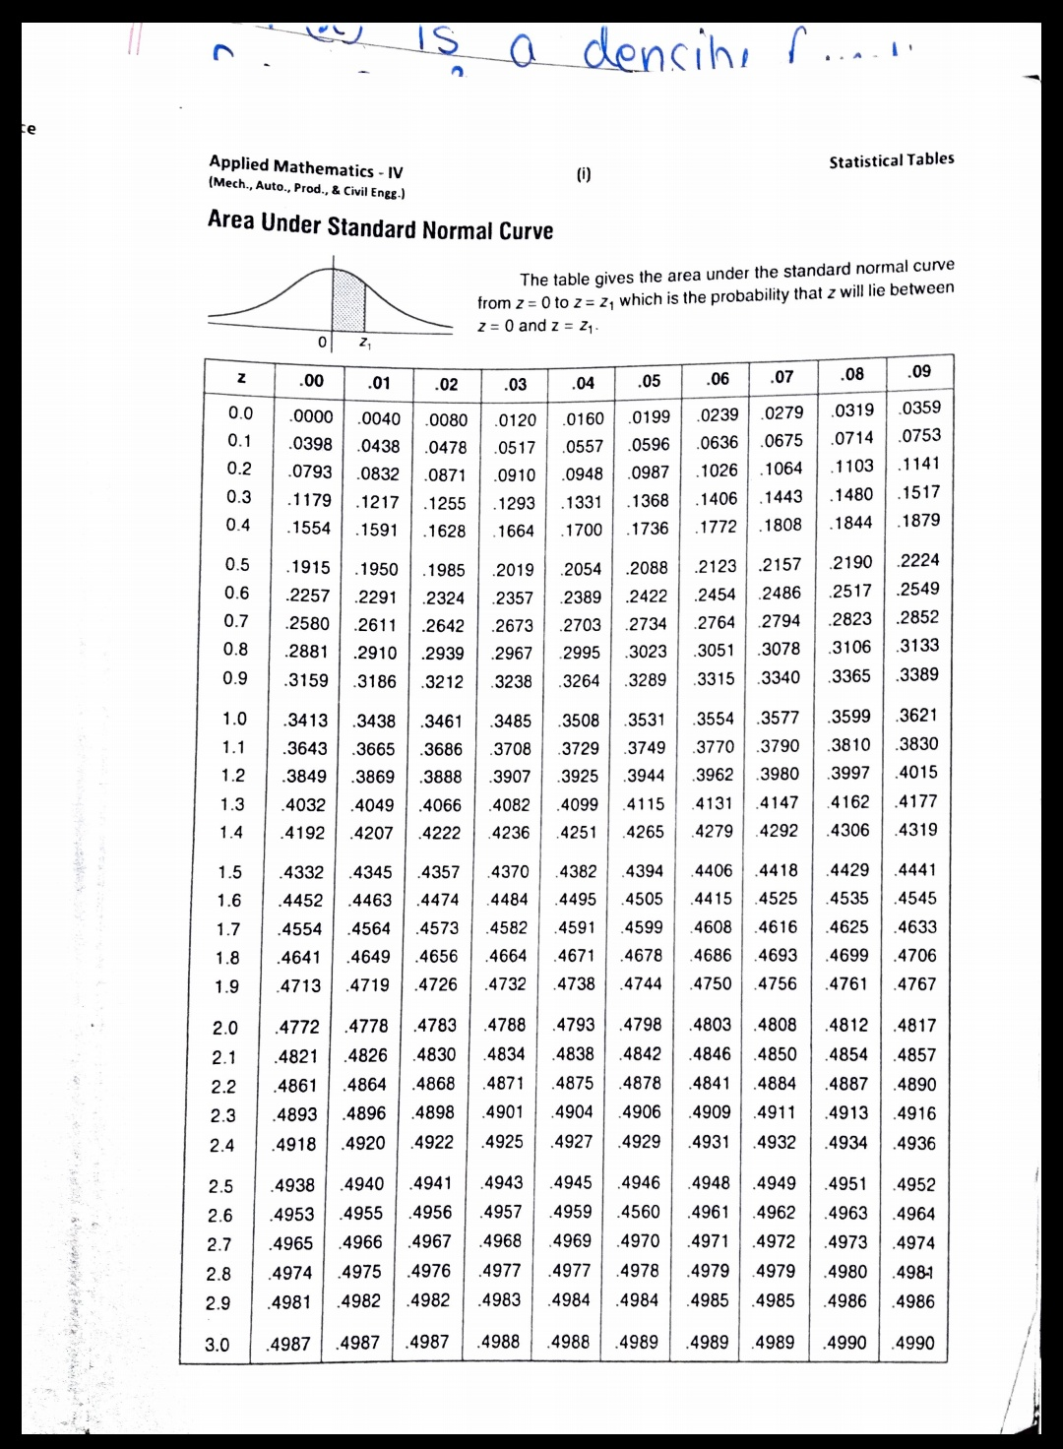

**ClassWork Problems**

|  |  |  |  |  |  |  |  |  |  |  |  |  |  |  |  |  |  |  |  |  |  |  |  |  |  |  |  |  |  |  |  |  |  |  |  |  |  |  |  |  |  |  |  |  |  |  |  |  |  |  |  |  |  |  |  |  |  |  |  |  |  |  |  |  |  |  |  |  |  |  |  |  |  |  |  |  |  |  |  |  |  |  |  |  |  |  |  |  |  |  |
| --- | --- | --- | --- | --- | --- | --- | --- | --- | --- | --- | --- | --- | --- | --- | --- | --- | --- | --- | --- | --- | --- | --- | --- | --- | --- | --- | --- | --- | --- | --- | --- | --- | --- | --- | --- | --- | --- | --- | --- | --- | --- | --- | --- | --- | --- | --- | --- | --- | --- | --- | --- | --- | --- | --- | --- | --- | --- | --- | --- | --- | --- | --- | --- | --- | --- | --- | --- | --- | --- | --- | --- | --- | --- | --- | --- | --- | --- | --- | --- | --- | --- | --- | --- | --- | --- | --- | --- | --- | --- | --- |
| |  |  | | --- | --- | | Q.01 | Find the Binomial distribution if the mean is 2 and variance is 4/3. | |  | 64/729,192/729,240/729,160/729,60/729,12/729,1/729. | | Q.02 | Out of 800 families with 4 children each, how many families would be expected to have   1. 2 boys and 2 girls 2. At least 1 boy 3. At most 2 girls 4. Children of both sexes.   Assume equal probability for boys and girls. | |  | 300,750,11/16,550 | | Q.03 | It is know that the probability of an item produced by a certain machine will be defective is 0.05. If the produced items are sent to the market in packets of 20, find the number of packets containing at least, exactly and at most 2 defective items in a consignment of 1000 packets by using Binomial distribution | |  | 184,264,920 | | Q.04 | Fit a binomial distribution for the following data:   |  |  |  |  |  |  |  |  | | --- | --- | --- | --- | --- | --- | --- | --- | | x | 0 | 1 | 2 | 3 | 4 | 5 | 6 | | f | 5 | 18 | 28 | 12 | 7 | 6 | 4 | | |  | |  |  |  |  |  |  |  |  | | --- | --- | --- | --- | --- | --- | --- | --- | | X | 0 | 1 | 2 | 3 | 4 | 5 | 6 | | F | 4 | 15 | 25 | 22 | 11 | 3 | 0 |   0.288,5.58 | | Q.05 | Find the mean, variance of the probability distribution of the number of heads obtained in three flips of a balanced coin. | | Q.06 | With usual notation find p of Binomial distribution if n=6, Also find mean, variance. | |  | ¼,3/2,9/8,9/16,45/32 | | Q.07 | An irregular 6 faced dice is such that the probability that it gives 3 even numbers in 5 throws. How many sets of exactly 5 trials can be expected to give no even number out of 2500 sets? | |  | 10 | | Q.08 | Two dice are thrown 120 times. Find the average number of times in which the number on the first die exceeds the number on the second die. | |  | 50 | | Q.09 | Find the mean and standard deviation of the following probability distribution.   |  |  |  |  |  |  |  |  |  |  | | --- | --- | --- | --- | --- | --- | --- | --- | --- | --- | | X=xi | 0 | 1 | 2 | 3 | 4 | 5 | 6 | 7 | 8 | | pi | 0.004 | 0.036 | 0.1 | 0.232 | 0.280 | 0.240 | 0.112 | 0.028 | 0.004 | | |  | [Ans. mean=3.972, SD=1.410] | | Q.10 | The sum and product of mean and variance of a Binomial distribution are 24 and 128. Find the distribution | |  | N=32, p=q=1/2 | |
| **(Poisson Distribution)**   |  |  | | --- | --- | | Q.01 | A variable X follows a Poisson distribution with variance 3. Calculate | |  | 0.224,0.353 | | Q.02 | The number of monthly breakdowns of a computer is a RV having a Poisson distribution with mean equal to 1.8. Find the probability that this computer will function for a month   1. Without a breakdown 2. With only one breakdown 3. With at least one breakdown | |  | 0.1653,0.2975,0.8347 | | Q.03 | Find the probability that at most 5 defective bulbs will be found in a box of 200 bulbs if it is known that 2% of the bulbs are defective. | |  | 0.7845 | | Q.04 | If the probability that an individual suffers a bad reaction from a certain injection is 0.001, determine the chance that out of 2000 individuals   1. Exactly 3 2. More than 2 3. None 4. More than 1   Individual will suffer a bad reaction. | |  | 0.180,0.323,0.135,0.594 | | Q.05 | A car hire firm has two cars which it hires out day by day. The number of demands for a car on each day is distributed as Poisson variate with mean 1.5. Calculate the proportion of days on which (i) neither car is used, (ii) some demand is refused | |  | Ans. 0.2231, 0.1912 | | Q.06 | Fit a Poisson distribution for the following: Also find mean, variance.   |  |  |  |  |  |  | | --- | --- | --- | --- | --- | --- | | x | 0 | 1 | 2 | 3 | 4 | | F | 123 | 59 | 14 | 3 | 1 | | |  | |  |  |  |  |  |  | | --- | --- | --- | --- | --- | --- | | x | 0 | 1 | 2 | 3 | 4 | | F | 121 | 61 | 15 | 3 | 1 |   0.5,0.5,0.5,1.25 | | Q.07 | Fit a Poisson distribution for the following data:   |  |  |  |  |  |  |  |  | | --- | --- | --- | --- | --- | --- | --- | --- | | x: | 0 | 1 | 2 | 3 | 4 | 5 | Total | | f: | 142 | 156 | 69 | 27 | 5 | 1 | 400 |   Also find mean, variance. | |  |  | | Q.08 | If a random variable X follows Poisson distribution such that , find the mean, variance, skewness and kurtosis of the distribution. Also find P(X=3). | |  | 1,1,1,4,0.06143 | | Q.09 | Find out the fallacy of the statement: “If X is a Poisson variate such that  Then mean of X is 1.” Also find mean, variance. | |  | Correct,1,1,1,4 | |
| **Normal distribution**   |  |  | | --- | --- | | Q.01 | In a normal distribution, 31% of the items are under 45 and 8% are over 64. Find the mean and standard deviation of the distribution? | |  | Ans: 50,10 | | Q.02 | In an intelligence test administered to 1000 students, the average was 42 and standard dard deviation was 24. Find the number of students   1. Exceeding the score 50 2. Between 30 and 54 | |  | Ans: 371, 383 | | Q.03 | If X is a normal random variable with parameters μ = 3 and σ2 = 9, find  (a) P{2 <X < 5}; (b) P{X > 0}; (c) P{|X – 3 |>6 | |  | Ans: 0.3779,0.8413, .0456 | | Q.04 | A sample of 100 dry battery cells tested to find the length of life produced the following results: Mean=12 hrs. SD=3 hrs. Assuming the data to be normally distributed, what percentage of battery cells are expected to have life   1. More than 15 hrs. 2. Less than 6 hrs. 3. Between 10 & 14 hrs. | |  | Ans: 15.87%,2.28%,49.74% | | Q.05 | If the actual amount of instant coffee which is filling machine puts into 6 ounce jars is a RV having a normal distribution with SD=0.05 ounce and if only 3% of the jars are to contain less than 6 ounces of coffee, what must be the mean fill of these jars? | |  | Ans: 0.47,6.094 | |
| |  |  | | --- | --- | | Q.06 | For a normal distribution with mean 2 and variance 9, find the value of X such that the probability of the interval (2, X) is 0.4115 | |  | Ans: X=6.05 | | Q.07 | The income of a group of 10000 persons were found to be normally distributed with mean rs 520 and S.D. Rs 60. Find (i) the number of persons having incomes between Rs 400 and Rs 550? (ii) The lowest income of the richest 500. | |  | Ans: 6687, Rs 618.40 | | Q.08 | For a normal variate X with mean 25 and standard deviation 10, find the area between (i) X = 25, X = 35, (ii) X = 15, X = 35 and also the area such that, (iii)  , (iv) .  Ans: 0.3413, 0.6826, 0.8413, 0.1587 | | Q.09 | If the height of 500 students is normally distributed with mean 68 inches and SD 4 inches, estimate the number of students having heights (i) greater than 72 inches, (ii) less than 62 inches, (iii) between 65 and 71 inches.  Ans: 79, 33, 273 | | Q.10 | Assume that the diameters of 1000 brass plugs taken consecutively from a machine form a normal distribution with mean 0.7515 inches and SD 0.0020 inches. How many of the plugs are likely to be rejected if the diameter is to be 0.752 0.004 inches?  Ans: 52 | | Q.11 | For a normally distributed variate X with mean 1 and s.d 3, find | |  | Ans: 0.1672, 0.4574 | |
| **Exponential Distribution**   |  |  | | --- | --- | | Q.01 | The mileage which car owners get a certain kind of radial tire is a RV having an exponential distribution with mean 40,000 km. Find the probabilities that one of these tires will last   1. At least 20,000 km 2. At most 30,000 km | |  | Ans: 0.6065,0.5270 | | Q.02 | The time in hrs required to repair a machine is exponentially distributed with parameter λ=1/2.   1. What is the probability that the repair time exceeds 2 hrs? 2. What is the conditional probability that a repair takes at least 10 hrs. given that its duration exceeds 9 hrs.? | |  | Ans: 0.3679,0.6065 | | Q.03 | A random variable X has an exponential distribution with pdf is given by:    Compute the probability that X is not less than 3. Also find mean, SD and  coefficient of variance . | |  | Ans: e-6, ½, ½, 1 | |
| **UNIFORM Distribution**   1. Suppose X is a random variable that has uniform distribution with a= 200, b= 250. Find 2. f(x) 3. P(X>230) 4. 20th percentile of this distribution   Ans: 1/50, 0.4, 210   1. If X is uniformly distributed with mean 1 and variance 4/3. Find P(X<0).   Ans: 1/4   1. Busses arrive at a specified stop at 15 min interval starting at 7 am, i.e they arrive at 7, 7:15,7:30…so on. If the passenger arrives at the stop at a random time that is uniformly distributed between 7 and 7:30 am. Find the probability that he waits 2. Less than 5 min for a bus. 3. Atleast 12 mins for a bus.   Ans: 1/3, 1/5   1. Show that for a rectangular distribution , Moment Generating function about origin is , Also show that moments of even order given by .  |  | | --- | | 1. Let X be uniformly distributed in . Calculate | | Ans: |  1. Find the Moment generating function, Mean and Variance of Uniform distribution.   Ans:   |  | | --- | | 1. If the random variable K is uniformly distributed over (0,5); what is the probability that the roots of the equation  are real? Ans: 3/5 | |

**Tutorial Problems**

|  |  |  |  |  |  |  |  |  |  |  |  |  |  |  |  |  |  |  |  |  |  |  |  |  |  |  |  |  |  |  |  |  |  |  |  |  |  |  |  |  |  |  |  |  |  |  |  |  |  |  |  |  |  |  |  |  |  |  |  |  |  |  |  |  |  |  |  |  |  |  |  |  |  |  |  |  |  |  |  |  |  |  |
| --- | --- | --- | --- | --- | --- | --- | --- | --- | --- | --- | --- | --- | --- | --- | --- | --- | --- | --- | --- | --- | --- | --- | --- | --- | --- | --- | --- | --- | --- | --- | --- | --- | --- | --- | --- | --- | --- | --- | --- | --- | --- | --- | --- | --- | --- | --- | --- | --- | --- | --- | --- | --- | --- | --- | --- | --- | --- | --- | --- | --- | --- | --- | --- | --- | --- | --- | --- | --- | --- | --- | --- | --- | --- | --- | --- | --- | --- | --- | --- | --- | --- | --- |
| **Tutorial 04**   |  |  | | --- | --- | | **Binomial Distribution** | | | Q.01 | What is the expectation of heads if an unbiased coin is tossed 12 times. | |  | 6 | | Q.02 | Find the binomial distribution if the mean is 4 and variance is 3. | |  | n=16,p=1/4,q=3/4 | | Q.03 | In a binomial distribution the mean is 5 and SD is 3.Find the fallacy if any in this statement. | |  | q can’t be greater than 1. | | Q.04 | The ratio of the probability of 3 successes in 5 independent trials to the probability of 2 successes in 5 independent trials is ¼. What is the probability of 4 successes in 6 independent trials? | |  |  | | Q.05 | Out of 800 families with 5 children each, how many families would be expected to have   1. 3 boys 2. 5 girls 3. Either 2 or 3 boys.   Assume equal probability for boys and girls. | |  | 250,25,300 | | Q.06 | Find binomial distribution if the mean is 5 and variance is 10/3. Find. | |  |  | | Q.07 | The probability of entering students in chartered accountant will graduate is 0.5. Determine the probability that out of 10 students   1. None 2. One 3. At least one will graduate. | |  |  | | Q.08 | Find the mean, variance of the probability distribution | |  |  | | Q.09 | Fit a binomial distribution for the following data: | |  | |  |  |  |  |  |  | | --- | --- | --- | --- | --- | --- | | x: | 0 | 1 | 2 | 3 | 4 | | f: | 5 | 29 | 36 | 25 | 5 |   Also find mean, variance. | | Q.10 | The following data are the number of seeds germinating out of 10 on damp filter for 80 sets of seeds. Fit a binomial distribution to these data.   |  |  |  |  |  |  |  |  |  |  |  |  | | --- | --- | --- | --- | --- | --- | --- | --- | --- | --- | --- | --- | | x | 0 | 1 | 2 | 3 | 4 | 5 | 6 | 7 | 8 | 9 | 10 | |  | 6 | 20 | 28 | 12 | 8 | 6 | 0 | 0 | 0 | 0 | 0 | | |  |  | | Q.11 | If 10% of the bolts are produced by a machine are defective, determine the probability that out of 10 bolts chosen at random;   1. One 2. None 3. At most two bolts will be defective. | |  | 0.3874,(9/10)10,0.9297 | |
| |  |  | | --- | --- | | **Poisson Distribution** | | | Q.01 | The number of road construction projects that take place at any one time in a certain city follows a Poisson distribution with a mean of 3. Find the probability that exactly five road construction projects are currently taking place in this city | |  | (0.100819) | | Q02 | The number of road construction projects that take place at any one time in a certain city follows a Poisson distribution with a mean of 7. Find the probability that more than four road construction projects are currently taking place in the city. | |  | (0.827008) | | Q.03 | The number of traffic accidents that occur on a particular stretch of road during a month follows a Poisson distribution with a mean of 7.6. Find the probability that less than three accidents will occur next month on this stretch of road. | |  | (0.018757) | | Q.04 | The number of traffic accidents that occur on a particular stretch of road during a month follows a Poisson distribution with a mean of 7. Find the probability of observing exactly three accidents on this stretch of road next month. | |  | (0.052129) | | Q.05 | In a certain factory turning out razor blades, there is a small chance of 0.002 for any blade to be defective. The blades are supplied in packets of 10, use Poisson distribution to calculate the approximate no. of packets containing no defective, one defective and two defective blades resp. in a consignment of 50000 packets. | |  | 49010,980,10 | | Q.06 | The frequency of accident per shift in a factory is given in the table below:   |  |  |  |  |  |  | | --- | --- | --- | --- | --- | --- | | x | 0 | 1 | 2 | 3 | 4 | | F | 192 | 100 | 24 | 3 | 1 |   Find the corresponding Poisson distribution and compare with actual observations. Also find mean, variance, skewness and kurtosis. | |  | |  |  |  |  |  |  | | --- | --- | --- | --- | --- | --- | | x | 0 | 1 | 2 | 3 | 4 | | F | 193.6 | 97.3 | 24.5 | 4.1 | 0.5 | | | Q.07 | Fit a Poisson distribution for the following data:   |  |  |  |  |  |  |  |  | | --- | --- | --- | --- | --- | --- | --- | --- | | x: | 0 | 1 | 2 | 3 | 4 | 5 | 6 | | f: | 314 | 335 | 204 | 86 | 29 | 9 | 3 |   Also find mean, variance. | | Q.08 | Find out the fallacy if any in the following statement: “The mean of a Poisson distribution is 2 and variance is 3.” | |  | False | | Q.09 | If X is a Poisson variate and P(X=0)=6P(X=3). Find out mean, variance, Also find P(X=2) | |

**Continuous Random Variables**

|  |  |  |
| --- | --- | --- |
| Q.01 | For the continuous random variable $X$, the probability density function given below $f\left(x\right)=\left\{\begin{aligned}k\left(2-x\right);0≤x<2 \\ kx\left(x-2\right);2≤x<3 \\ 0 ; \text{otherwise}\end{aligned}\right..$   Find k, mean and distribution function.  Ans: k=3/10, 59/40, | |
| Q.02 | A daily consumption of electric power (in million kWh) is a random variable X with probability density function given below    Find (i) $k$ (ii) expectation of X (iii) Probability that on a given day, the electric consumption is more than expected value. | |
|  | Ans:1/9, 6, 0.406 | |
| Q.03 | The distribution function of a continuous random variable $x$ is given by $F\left(x\right)=1-\left(1+x\right)e^{-x} , x≥0$ . Find the probability density function, mean and standard deviation | |
|  | $$f\left(x\right)=xe^{-x}, 2, \sqrt{2}$$ | |
| Q.04 | If pdf:    Then find k and cdf | |
|  | Ans: | |
| Q.05 | A continuous random variable has probability density function $f\left(x\right)=6\left(x-x^{2}\right),$ $0≤x≤1$.  Find mean and variance and also find. | |
|  | Ans:1/2, 1/20, 0.6264 | |
| Q.06 | A continuous RV X that can assume any value between x=2 and x=5 has a density function given by f(x)=k(1+x). Find P(X<4) | |
|  | Ans:16/27 | |
| Q.07 | A RV X has the density function:  Find the distribution function. | |
|  | Ans: | |
| Q.08 | If  has pdf, determine k and find  and find a if | |
|  | Ans:19/216,(0.95)1/3 | |
| **Normal Distribution** | | | |
| Q.01 | | A normal variable X has a mean of 25.5. It is known that 42.36% of the X values are more than 27. Find the standard deviation of X. | |
|  | | $$σ=7.9$$ | |
| Q.02 | | In a sample of 1000 cases, the mean of a certain test is 14 and standard deviation is 2.5. Assuming the distribution to be normal, find   1. How many students score between 12 and 15? 2. How many score above 18? 3. How many score below 8? 4. How many score 16? | |
|  | | Ans:444, 55, 8, 116 | |
| Q.03 | | A manufacturer of envelopes known that the weight of the envelopes is normally distributed with mean 1.9 gm and variance 0.01 gm. Find how many envelops weighting (i) 2 gm or more (ii) 2.1 gm or more can be expected in a given packet of 1000 envelopes | |
|  | | Ans:159, 23 | |
| Q.04 | | The life of army shoes is normally distributed with mean 8 months and standard deviation 2 months. If 5000 pairs are issued how many pairs would be expected to need replacement after 12 months? | |
|  | | Ans:4886 | |
| Q.05 | | In a male population of 1000, the mean height is 68.16 inches and standard deviation is 3.2 inches. How many men may be more than 6 feet (72 inches)? | |
|  | | Ans:115 | |
| Q.06 | | Marks obtained by students in an examination follow normal distribution. If 30% of students got below 35 marks and 10% got above 60 marks, Find the mean and standard deviation.  Ans:13.83, 42.26 | |
|  | |  | |
| **Exponential Distribution** | | | |
| Q.07 | | Suppose the life of mobile batteries is exponentially distributed with parameter λ=0.001 days, What is the probability that a battery will last more than 1200 days? | |
|  | | Ans: 0.301 | |
| Q08 | | The income tax, of a man has exponential distribution with pdf is given by:    If income tax is levied at the rate of 5%, what is the probability that his income exceed Rs. 10,000? | |
|  | | Ans: e-125 | |
| Q.09 | | Suppose that the length of a phone call in minutes is an exponential random variable with parameter λ=1/10 . If someone arrives immediately ahead of you at a public  telephone booth, find the probability that you will have to wait  (a) More than 10 minutes;  (b) Between 10 and 20 minutes. | |
|  | | Ans:0.368,0.233 | |

|  |
| --- |
| **Uniform Distribution**   1. A point P is taken at random on a line AB of length 2a; all positions of the point being equally likely. Find the probability that the product (AP x PB) >  . Ans: 2. Find the third and fourth moment about the mean of a uniform distribution defined in the interval a < X < b.   Ans: |
| 1. From past experience, Mr. A has found that the low bid on a construction job can be regarded as a random variable having uniform density  where C is his own estimate of the cost of the job. What percentage should Mr.A add to his cost estimate when submitting bids to maximize his expected profit? Ans: 50% |